Maths year 9 & 10 summer resources

Number
- Standard Form – page 2
- Lowest Common Multiple and Highest Common Factor – page 3
- Percentages – page 4
- Ratio – page 5
- Sequences – page 6
- Exam questions – page 7

Standard Form
Convert 1-6 into standard form and 7-12 from standard form
- 1,000,000 =  - 200 =  - 400,000 =  - 0.002 =  - 0.1 =  - 0.000006 = | - 3 x 10⁶  - 4 x 10⁷  - 9 x 10³  - 4 x 10⁻⁴  - 7 x 10⁻⁶  - 8 x 10⁻²

Convert 1-6 from standard form and 7-12 into standard form
- 2.34 x 10³  - 6.25 x 10⁴  - 9.03 x 10⁵  - 8.882 x 10⁻⁴  - 3.56 x 10⁻⁵  - 8.01 x 10⁻³ | - 12,000,000  - 99,000  - 1,380,000,000  - 0.0086  - 0.00086  - 0.000455

Perform these calculations
- (1.2 x 10⁴ ) + (5.3 x 10⁴ )
- (5.4 x 10⁴ ) + (2.2 x 10⁵ )
- (7.3 x 10⁶ ) - (5.4 x 10⁵ )
- (7.2 x 10⁵ ) + (3.5 x 10⁵ )
- (3.9 x 10⁻³ ) + (4.7 x 10⁻⁴ )
- (9.4 x 10¹⁵ ) - (2.2 x 10¹⁴ )

Prime Factors, Lowest Common multiple and Highest Common Factor

Write out these numbers as a product of their prime factors
- 15
- 24
- 32
- 80
- 144
- 170

Find the Lowest Common Multiple of the following numbers
- 27 and 36
- 36 and 90
- 24 and 30
- 20 and 30
- 45 and 75
- 100 and 120

Find the Highest Common Factor of the following numbers

- 160 and 200
- 264 and 308
- 108 and 144
- 40 and 72
- 90 and 108
- 36 and 96

Find the HCF and LCM of the following numbers
- 22 and 33
- 100 and 150
- 104 and 156
- 108 and 162
- 84 and 24
- 162 and 36

Percentages

Use a calculator to calculate these percentages 1-6 and try 7-12 without a calculator
- 10% of 50  - 25% of 300  - 21% of 900  - 17% of 600  - 33% of 255  - 14% of 862 | - 10% of 90  - 50% of 120  - 25% of 40  - 10% of 200  - 25% of 20  - 75% of 180

Use a calculator to solve the following percetage problems
- A shirt costing £20 has 10% off in a sale. How much would you pay for the shirt?
- A sofa costing £400 has 25% off in a sale. How much would you pay for the sofa?
- A family meal costs £55 and your Dad leaves a 10% tip. How much does he leave?
- Tim measures 120cm in height. His broth Phil is 25% shorter. How tall is Phil?

Complete these problems without a calculator

- Ben and Sam have a bag containing 48 sweets. Whilst watching a film they eat 75% of the sweets. How many are left?
- Trainers are usually £30 but this week they have been reduced by 10%. What is the price of trainers this week?
- Mr. Smith wants to buy a new car. He finds a car he likes for £5500 and then manages to negotiate 10% off the price. How much does he pay?
Use a calculator to solve these problems.
- By selling a car for £2500, Ben made a profit of 25%. How much did he pay for it?
- A company makes a profit for the year of £75,000 before tax is paid. What percentage tax does it pay if its tax bill amounts to £11,250?
- Rachel invests £1500 in a bank account which pays interest of 6.5% per annum.
- How much interest has she earned at the end of 1 year?
- She has to pay tax on this interest at 22%. How much tax does she pay?
- The population of a certain town was 50,000 at the beginning of 1998. It is expected to rise by 7% each year until the end of the year 2000. What is the expected population at the end of this period?
Ratio
Complete the table
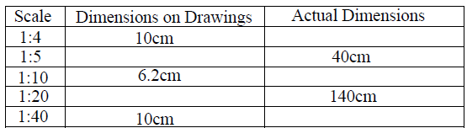
Divide each of the following into the ratios given
- £900 into the ratio 4:5
- £1000 into the ratio 3:7
- £200 into the ratio 3:5
- £600 into the ratio 7:8
- £800 into the ratio 5:11
- £700 into the ratio 5:9

Complete these mixed problems.
- Kitchen flooring is sold at £8 per 1m. Find the cost of the following lengths:
- 5m
- 50cm
- 80cm
- Scott ate most of the 32kg wedding cake at a wedding before he was escorted out. The ratio of the cake between him, the bridge and the groom was 5:1:2. How much of the cake did each person get?
- A school employs teachers in the ratio 1:20 to the number of children.
- If the school has 600 children, how many teachers does it need?
- If the school has 15 teachers, how many children can it take?
- Phoenix College employs staff to a ratio of 1:4 students. If there are 1000 people in the college. How many staff and students are there?
Three people, A, B and C, share an amount of money in the ratios shown below. In each case calculate the total amount of money shared out and the amount C gets.
- Ratio 2:3:4. A gets £8
- Ratio 3:4:5. B gets £12
- Ratio 3:8:10. B gets £24
- Ratio 3:5:7. A gets £33
- Ratio 7:11:14. B gets £99
- Ratio 3:5:11. A gets £1.65

Sequences

What are the next two terms in the following sequences.
- 2, 5, 8, 11, 14, 17
- 1, 5, 9, 13, 17, 21
- 4, 5, 7, 10, 14, 19
- 2, 2, 3, 5, 8, 12
- 17, 19, 22, 26, 31, 37
- 20, 19 , 17, 14, 10, 5
- 10, 8, 6, 4, 2, 0
- 15, 14, 11, 6, -1, -10

Find the n^{th} term of the following sequences
- 4, 7, 10, 13, 16, 19
- -3, 2, 7, 12, 17, 22
- 2, 5, 8, 11, 14, 17,
- 1, 5, 9, 13, 17, 21
- -2, -6, -10, -14, -18, -22
- 8, 3, -2, -7, -12, -17
- 39, 31, 23, 15, 7, -1
- 6, 11, 16, 21, 26, 31

Find the next two number and the n^{th} term of the following sequences
- 3, 6, 11, 18, 27, 38
- -6, -3, 2, 9 , 18, 29
- 0, 1, 4, 9 , 16, 25
- 0, 2, 6, 12, 20, 30
- 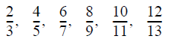
- 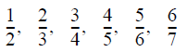
- 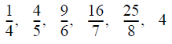
- 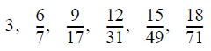

Number GCSE questions
Jun 12 paper 1
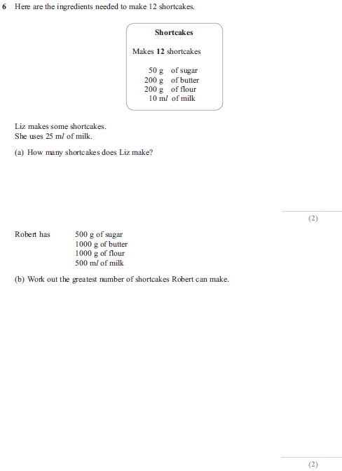

Jun 12 paper 1
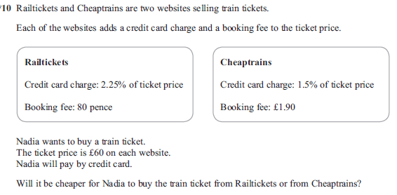

Jun 12 paper 1 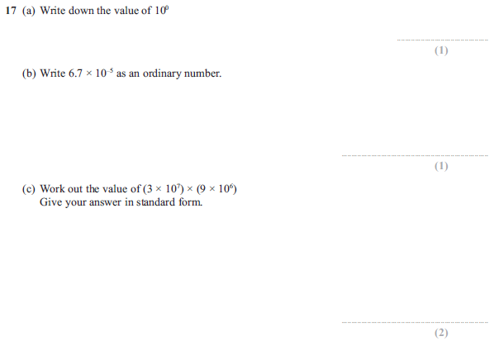
Jun 12 paper 2
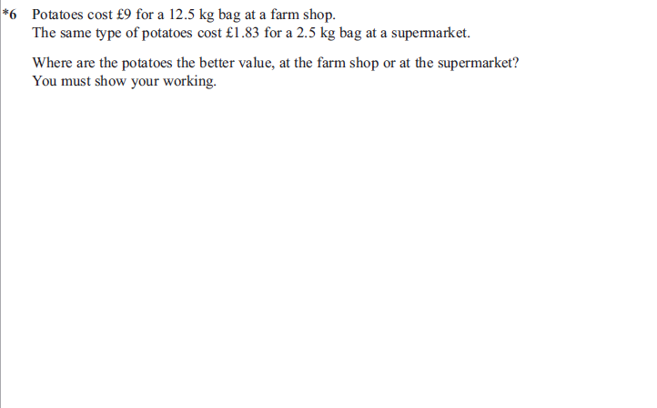

Jun 12 paper 2
Jun 12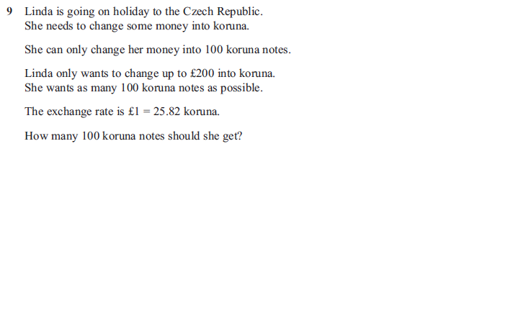
Jun 12 paper 2
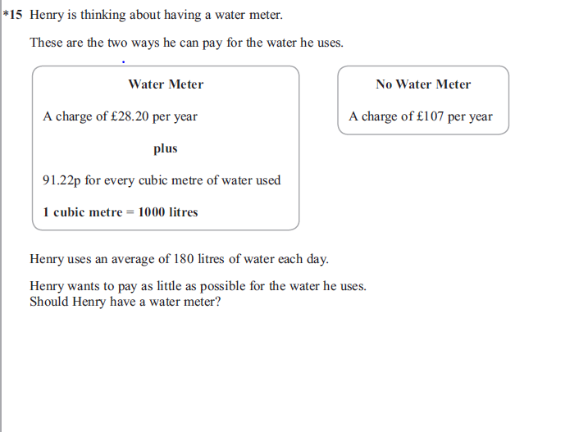
Jun 12 paper 2
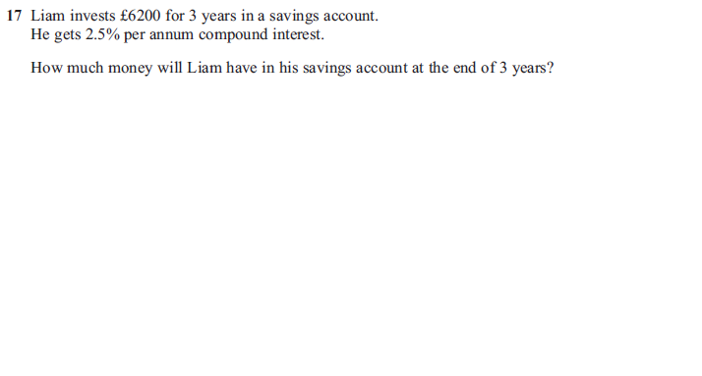
Nov 12 paper 1
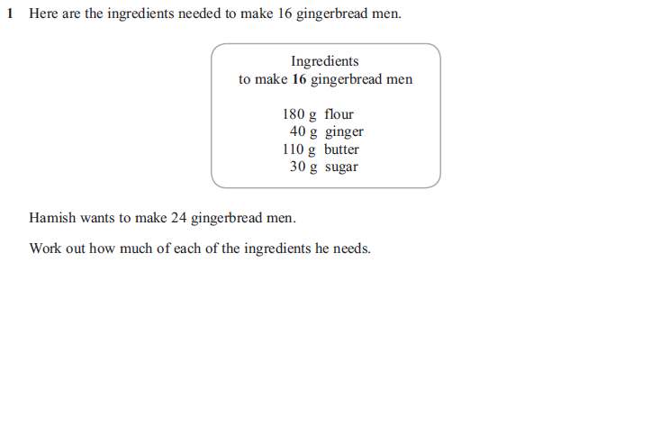

Nov 12 paper 1
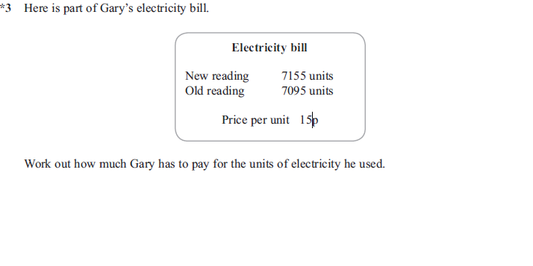
Nov 12 paper 1
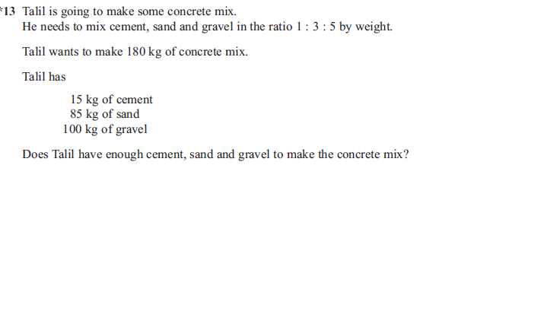

Nov 12 paper 1
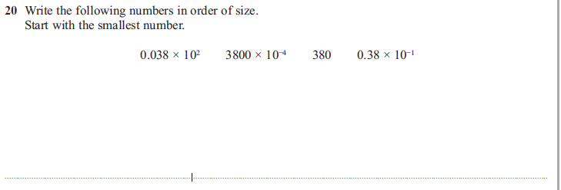
Nov 12 paper 2
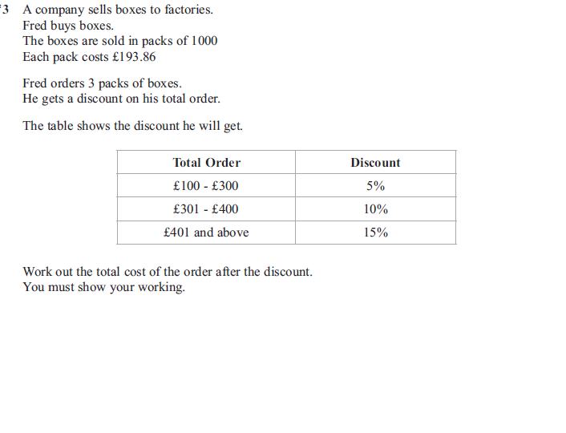

Nov 12 paper 2
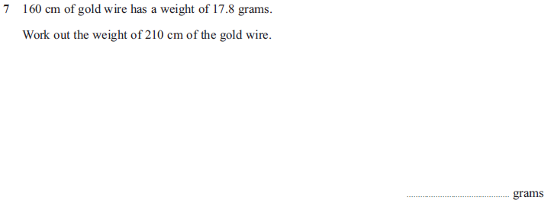
Nov 12 paper 2
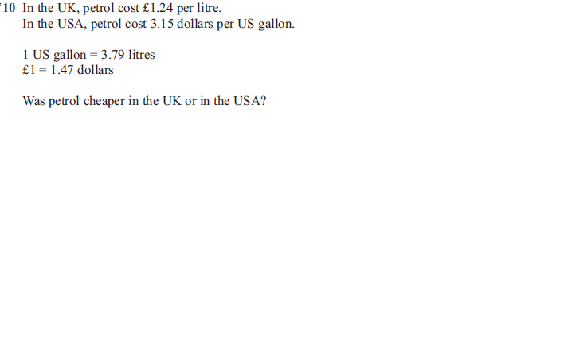
Nov 12 paper 2
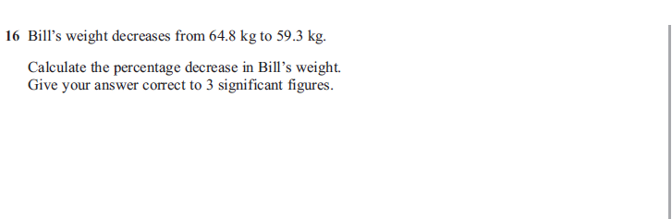

Nov 12 paper 2
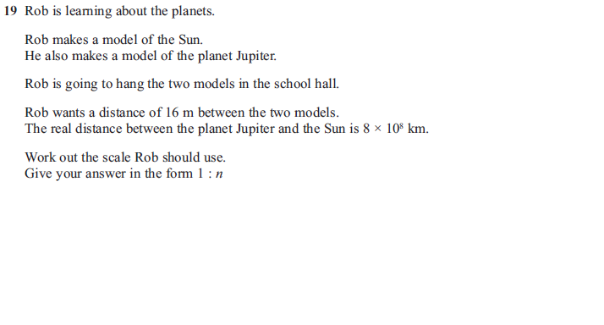
Nov 13 paper 2
