Maths year 7 & 8 summer resources

YEAR 7 & 8
TOPICS
Integer place value
Mental addition and subtraction
Written addition and subtraction of integers
Addition and subtraction of decimals
Multiplication and division of integers
Area
Multiplication and division of decimals
Mean
Time

The rest of this booklet contains questions in the style that you will find in the assessment. Plan to do 2 page per week– or follow your teacher’s instructions.

1.

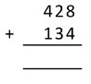 2 marks 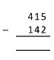 2 marks

- Write these numbers in order from smallest to largest

16, 123, 73, 140, 77

1 marks

- Write down the value of the 3 in the number 42 398

1 marks

4.

work out

  - 7 x 10

………………..

  - 3.6 x 100

………………...
  - 0.054 x 100

…………………………
  - 6000 ÷ 100

………………………….
  - 0.84 ÷ 10

…………………..

(5 marks)

5. (a) Round 342 to the nearest ten

(1mark)

(b) Round 12 831 to the nearest thousand

(1mark)

6.
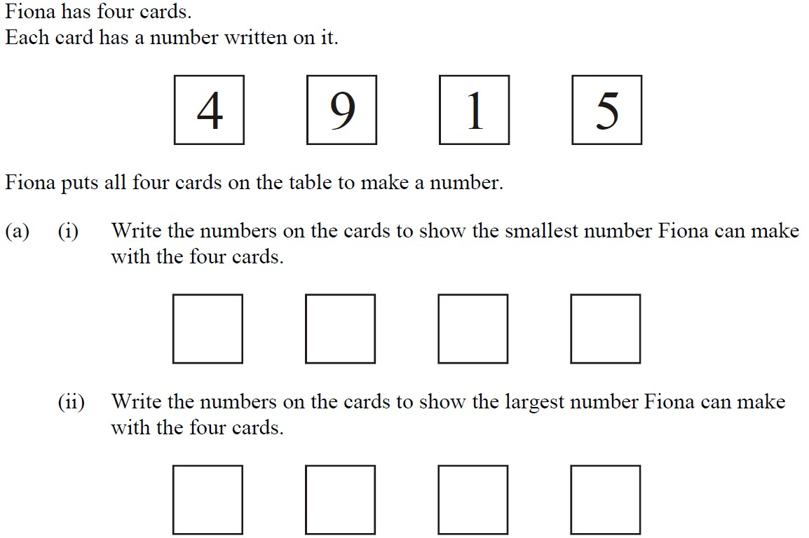
1 mark

1 mark
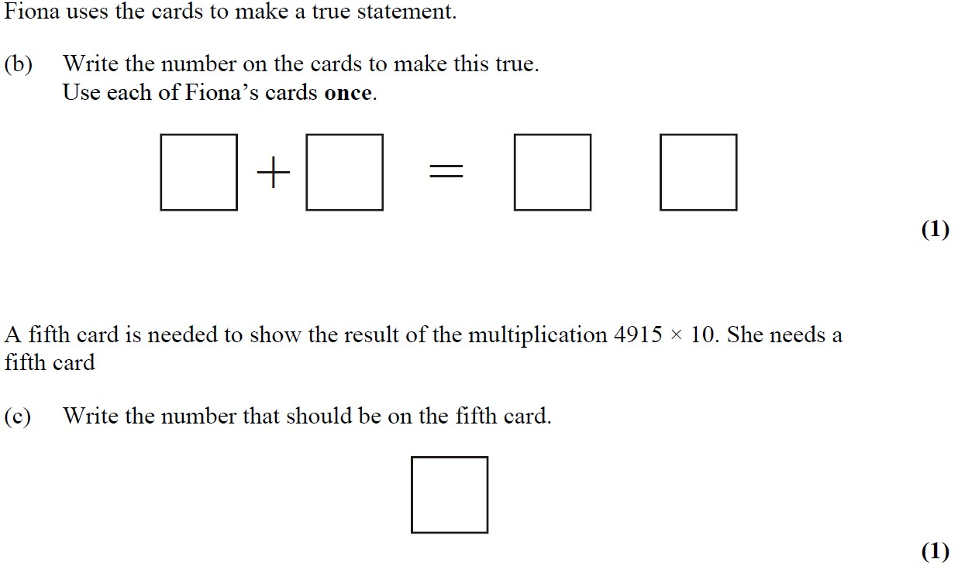
1 mark
1 mark

7.
Tony has a hot-dog stall.
He uses sauce from a bottle which holds 224 ml.
He puts about 7 ml of sauce on each hot-dog.
How many hot-dogs can he put sauce on from one bottle?

(2marks)
8.

(3 marks)
- Calculate the perimeter of the shape below giving units with your answer
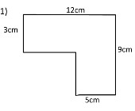

  - marks)

- The three triangles in the diagram below are exactly the same. Calculate the total area of the shape. Give units with your answer
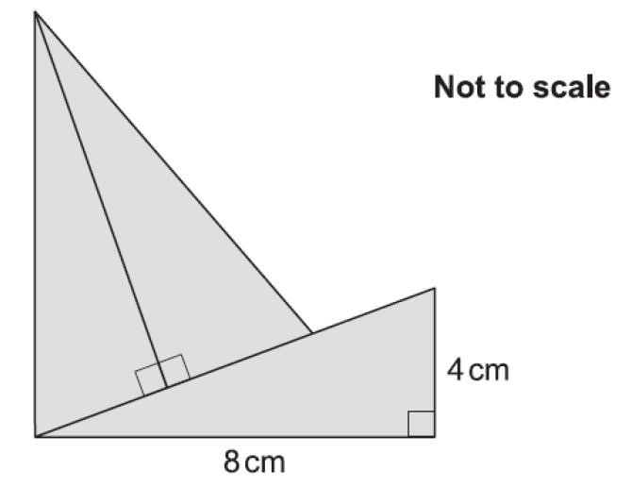

- Write the number 7428 in words.

.............................................................................................................................................
(1)

The mountain K3 is eight thousand and fifty one metres high.
- Write the number eight thousand and fifty one in figures.

...........................................................

The table shows the heights of six mountains.
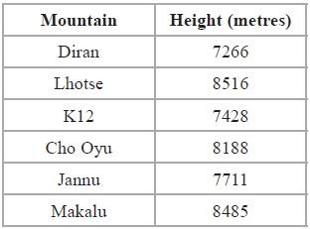

- Write down the name of the highest of these mountains.

...........................................................

- Write the number 8188 to the nearest hundred.

...........................................................

(1)

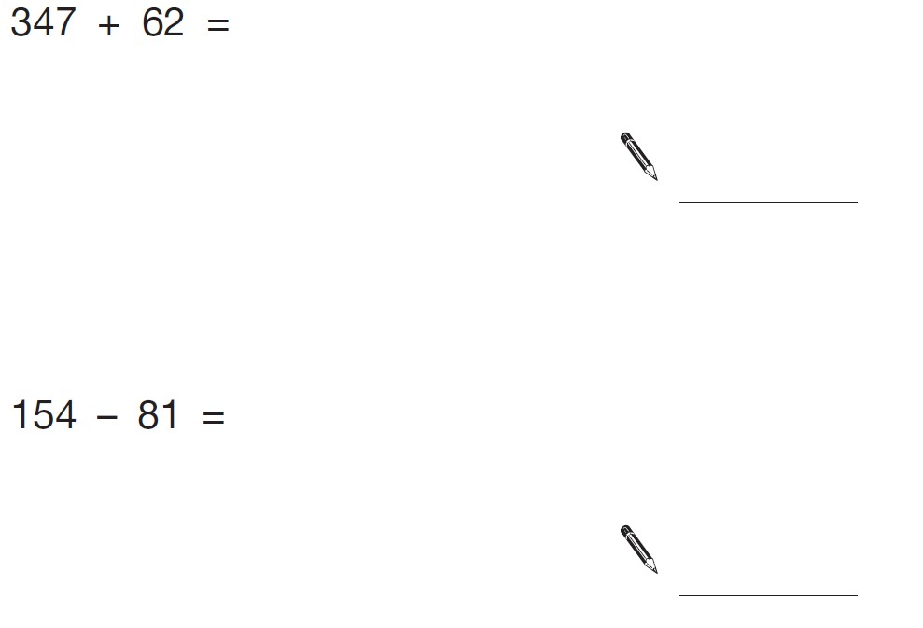
(2)

(2)

(2)

(2)

Write the correct symbol =, < or > in each circle

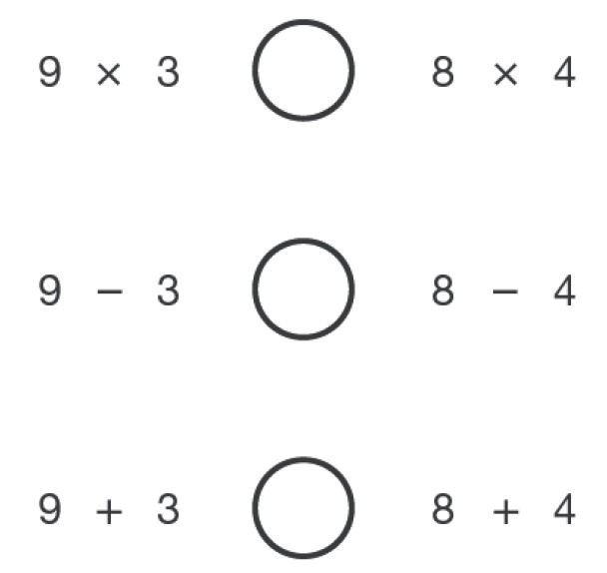
(3)
- Write these numbers in order of size, starting with the smallest.

3.01 13.0 0.31 1.30 3.1

Smallest
2 marks

- Complete the table by rounding each number to the accuracy given at the top of the column.
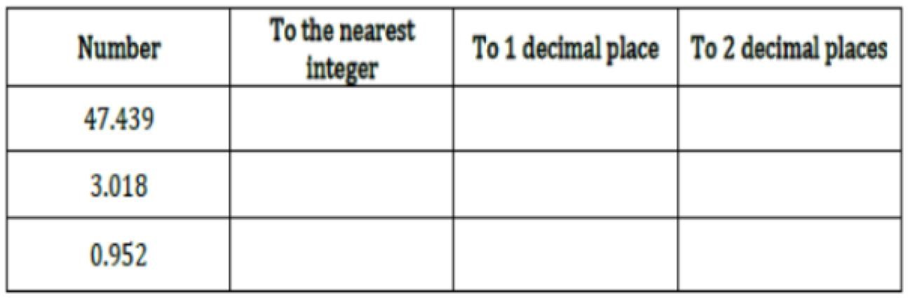

6.
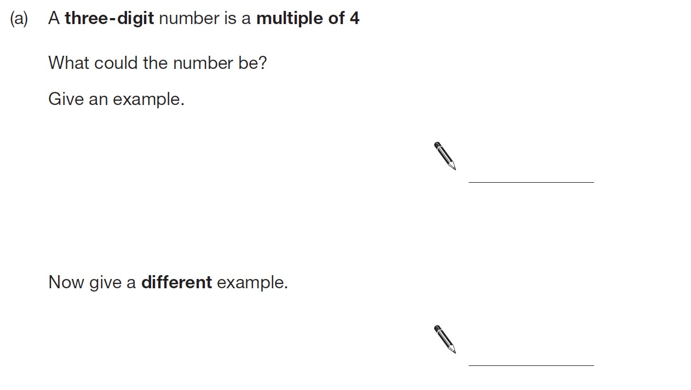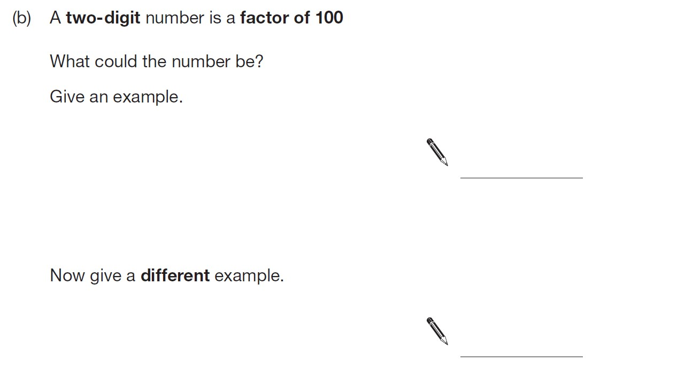
1
mark

1
mark

1
mark

1 mark

7.
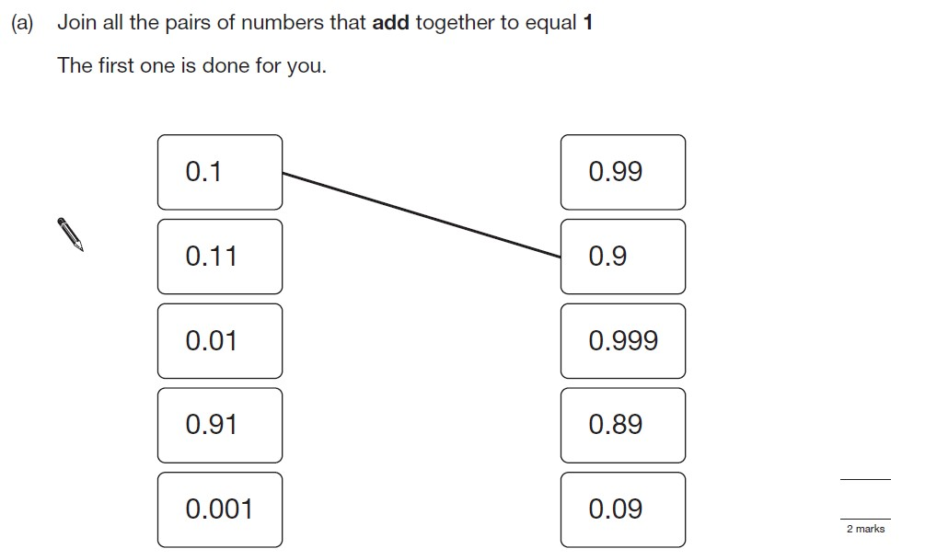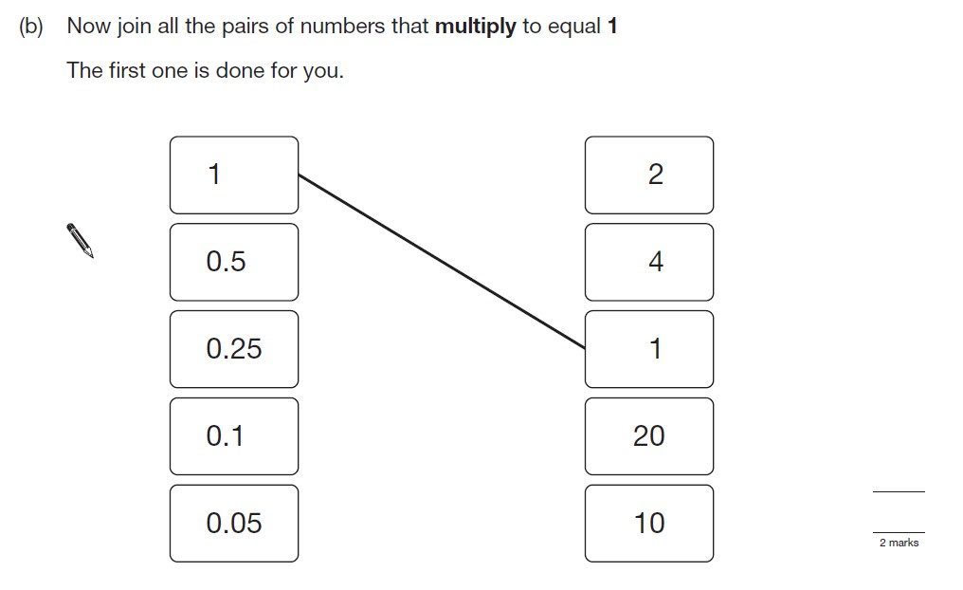

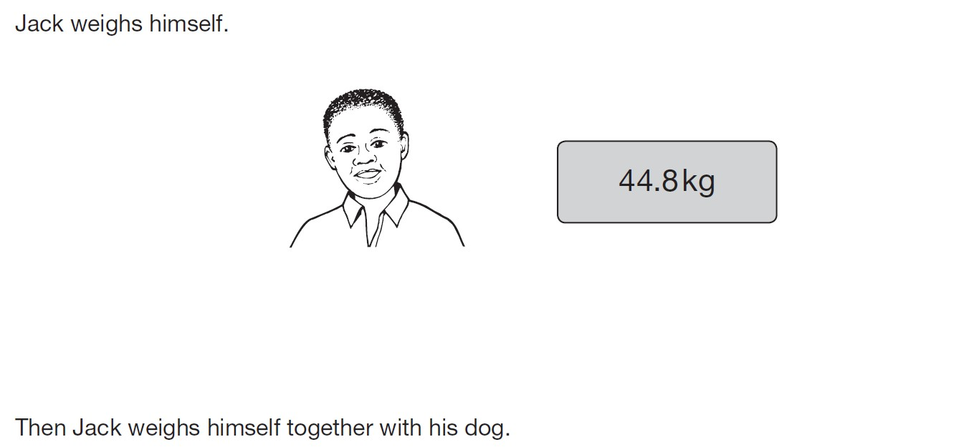
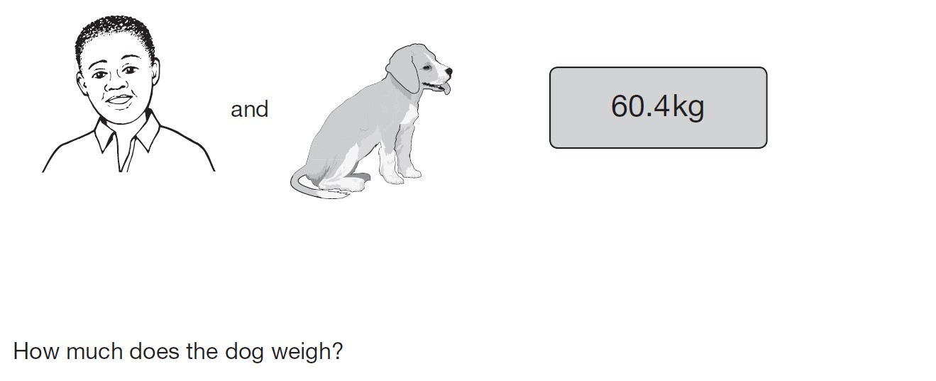
8.

3 mark

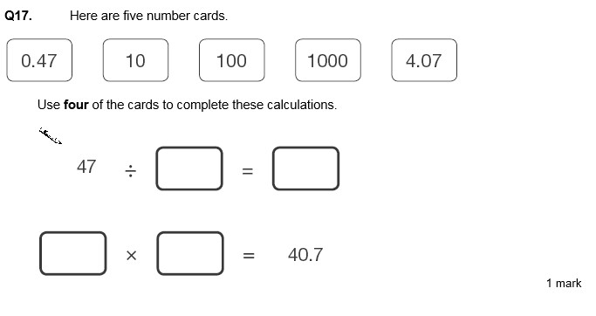
9.

2
mark

You can use each card only
once

10.
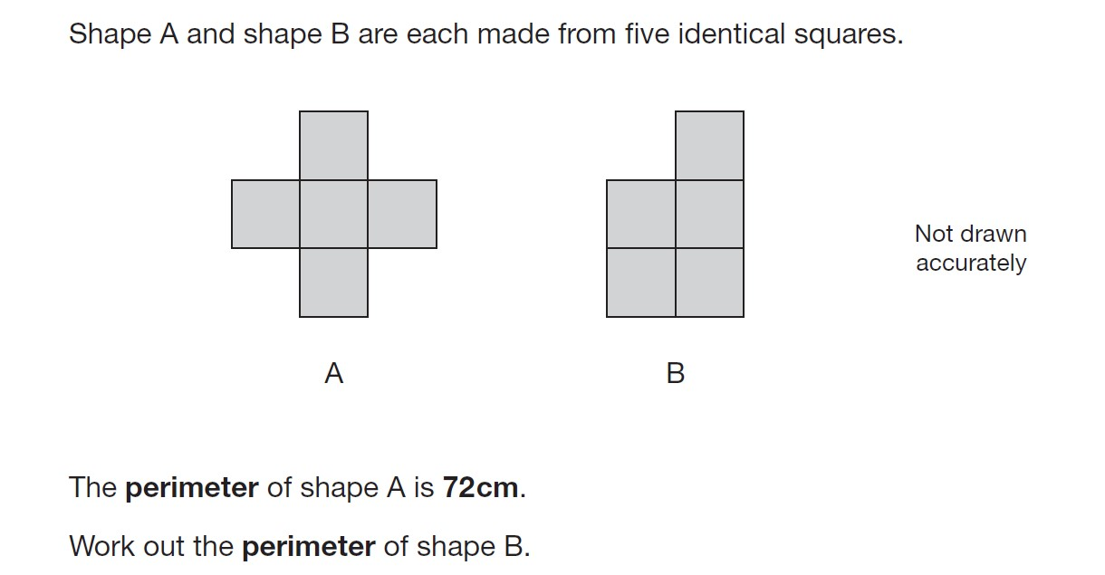

3 mark

11.

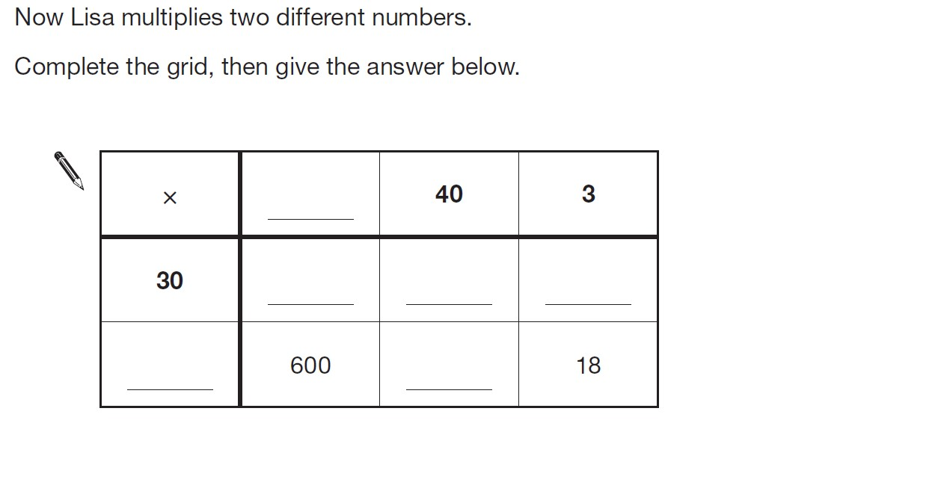
4
mark

12.

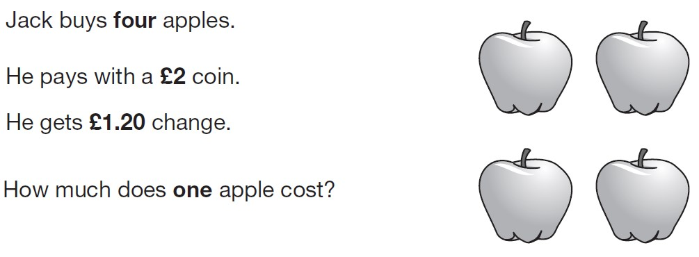
3 mark
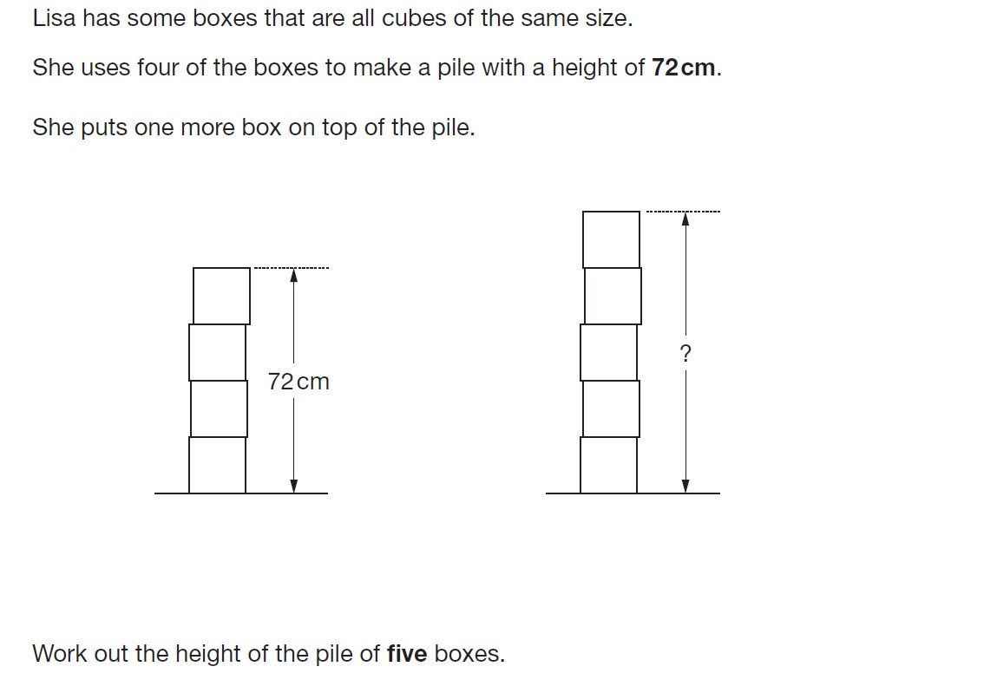
13.

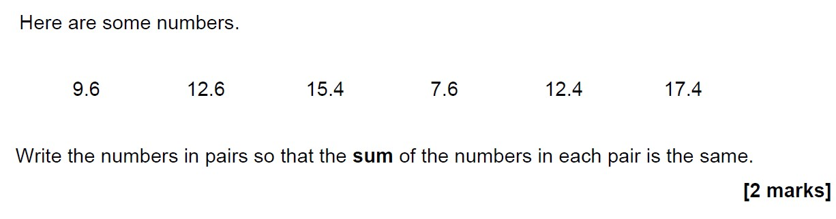
14.

15.

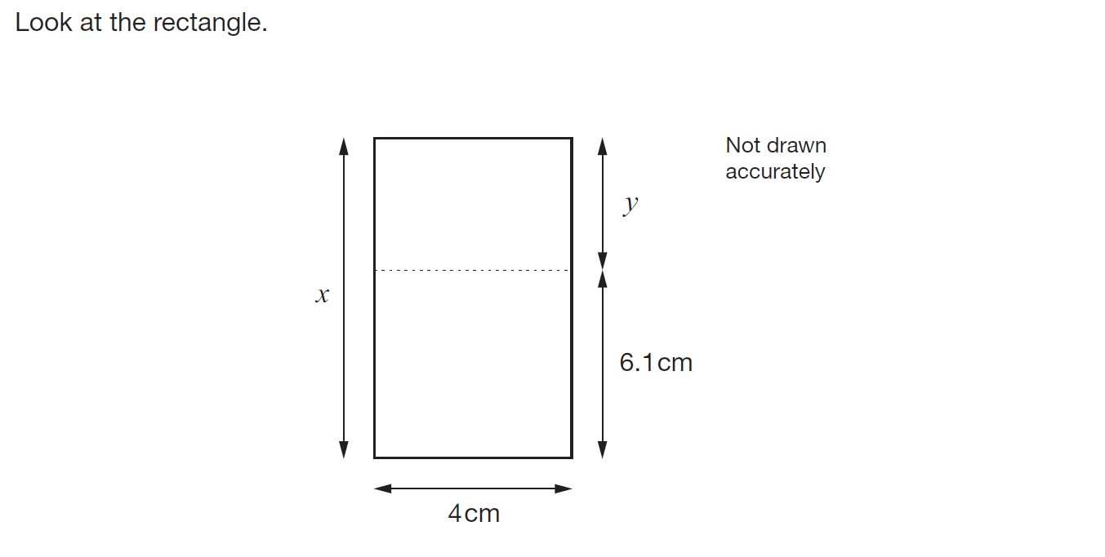

3 mark

16.

